**WEEK 5**

**CREATING MICROSERVICES FOR ACCOUNT AND LOAN**

**PROGRAM**

**AccountController.java**

package com.cognizant.account.controller;

import org.springframework.web.bind.annotation.*;

import java.util.Map;

@RestController

public class AccountController {

@GetMapping("/accounts/{number}")

public Map<String, Object> getAccount(@PathVariable String number) {

return Map.*of*(

"number", number,

"type", "savings",

"balance", 234343 ); }

}

**OUTPUT**

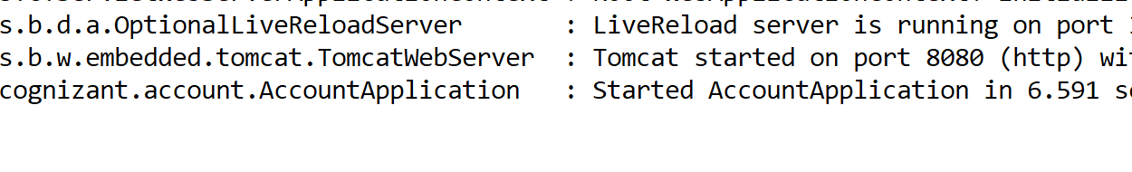

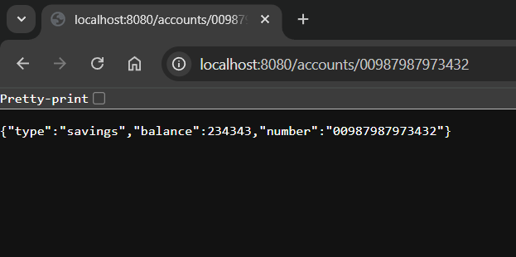

**LoanController .java**

package com.cognizant.loan.controller;

import org.springframework.web.bind.annotation.*;

import java.util.Map;

@RestController

public class LoanController {

@GetMapping("/loans/{number}")

public Map<String, Object> getLoan(@PathVariable String number) {

return Map.*of*(

"number", number,

"type", "car",

"loan", 400000,

"emi", 3258,

"tenure", 18

);}

}

**OUTPUT**

**LoanApplication.java**



